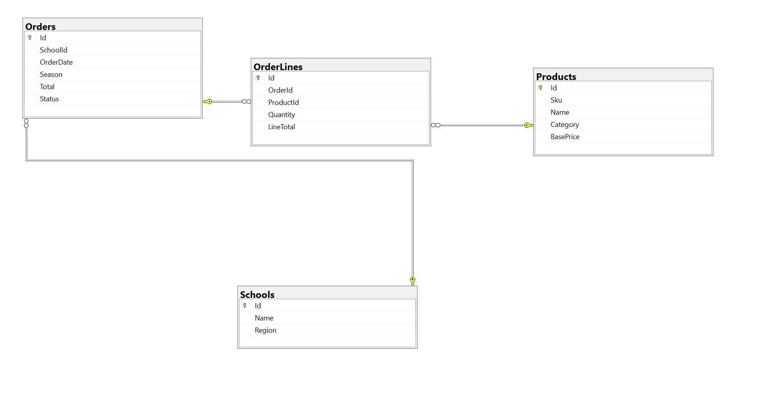

------------------Create tables scripts---------------------------
CREATE TABLE Schools (
Id INT IDENTITY(1,1) NOT NULL,
Name VARCHAR(200) NOT NULL,
Region VARCHAR(50) NULL,

CONSTRAINT PK_Schools PRIMARY KEY CLUSTERED (Id)
);

CREATE TABLE Products (
Id INT IDENTITY(1,1) NOT NULL,
Sku VARCHAR(50) NOT NULL,
Name VARCHAR(200) NOT NULL,
Category VARCHAR(50) NOT NULL,
BasePrice DECIMAL(10,2) NOT NULL,

CONSTRAINT PK_Products PRIMARY KEY CLUSTERED (Id),
CONSTRAINT UQ_Products_Sku UNIQUE (Sku)
);
CREATE INDEX IX_Products_Category ON Products (Category) INCLUDE (Id, Name);

CREATE TABLE Orders (
Id INT IDENTITY(1,1) NOT NULL,
SchoolId INT NOT NULL,
OrderDate DATE NOT NULL,
Season VARCHAR(20) NOT NULL, -- e.g. 'Back-to-School', 'Winter'
Total DECIMAL(12,2) NOT NULL,
Status VARCHAR(20) NOT NULL DEFAULT 'COMPLETE',

CONSTRAINT PK_Orders PRIMARY KEY CLUSTERED (Id),
CONSTRAINT FK_Orders_Schools FOREIGN KEY (SchoolId) REFERENCES Schools (Id)
);
-- Composite index supporting the date-range + school grouping
CREATE INDEX IX_Orders_SchoolId_OrderDate ON Orders (SchoolId, OrderDate)
INCLUDE (Season, Total);

CREATE TABLE OrderLines (
Id INT IDENTITY(1,1) NOT NULL,
OrderId INT NOT NULL,
ProductId INT NOT NULL,
Quantity INT NOT NULL,
LineTotal DECIMAL(12,2) NOT NULL,

CONSTRAINT PK_OrderLines PRIMARY KEY CLUSTERED (Id),
CONSTRAINT FK_OrderLines_Orders FOREIGN KEY (OrderId) REFERENCES Orders (Id),
CONSTRAINT FK_OrderLines_Products FOREIGN KEY (ProductId) REFERENCES Products (Id)
);

-- Trade-off: a nonclustered COLUMNSTORE index on the analytics columns.
-- This table is write-heavy during checkout but read-heavy (full scans/aggregates)
-- on the analytics page. NCCI gives huge compression + batch-mode aggregation
-- for the reporting query without touching the OLTP clustered index used by ProcessOrder.
CREATE NONCLUSTERED COLUMNSTORE INDEX NCCI_OrderLines_Analytics
ON OrderLines (OrderId, ProductId, Quantity, LineTotal);

-- Standard rowstore index to keep OLTP joins (e.g. "lines for this order") fast
CREATE INDEX IX_OrderLines_OrderId_ProductId ON OrderLines (OrderId, ProductId);

-------------------------------------------------------------------------

--Year-on-year revenue query--------
WITH yearly AS (
SELECT
s.Id AS SchoolId,
s.Name AS SchoolName,
o.Season,
p.Category,
YEAR(o.OrderDate) AS OrderYear,

SUM(ol.LineTotal) AS Revenue
FROM OrderLines ol
JOIN Orders o ON o.Id = ol.OrderId
JOIN Schools s ON s.Id = o.SchoolId
JOIN Products p ON p.Id = ol.ProductId
-- Trade-off: filter on a large date RANGE (last 2 full years),
-- not a function over OrderDate, so IX_Orders_SchoolId_OrderDate / NCCI
-- can actually be used for elimination instead of a full scan.
WHERE o.OrderDate >= DATEADD(YEAR, -1, DATEFROMPARTS(YEAR(GETDATE()), 1, 1))
AND o.Status = 'COMPLETE'
GROUP BY s.Id, s.Name, o.Season, p.Category, YEAR(o.OrderDate)
)
SELECT
SchoolName,
Season,
Category,
OrderYear,
Revenue,
-- Trade-off: LAG() over a window instead of a self-join to "last year".
-- Cheaper than a second pass over 8M rows, at the cost of needing
-- a deterministic ORDER BY per partition (school/season/category).
LAG(Revenue) OVER (
PARTITION BY SchoolName, Season, Category
ORDER BY OrderYear
) AS PriorYearRevenue,
Revenue - LAG(Revenue) OVER (
PARTITION BY SchoolName, Season, Category
ORDER BY OrderYear
) AS YoYDelta
FROM yearly
ORDER BY SchoolName, Season, Category, OrderYear;

-----------------------------------------
--The biggest risk in the current setup is that OrderLines.ProductId doesn't exist — the join to Products is done via Sku (a VARCHAR). String joins across an 8M-row table are more expensive than int joins

--Recommended:
--Add ProductId INT to OrderLines, and use it for the joins.

